Ryan Coon

CST-339

Dr. Brandon Bass

Activity 1

1/17/2022

Spring Tools Suite About Box

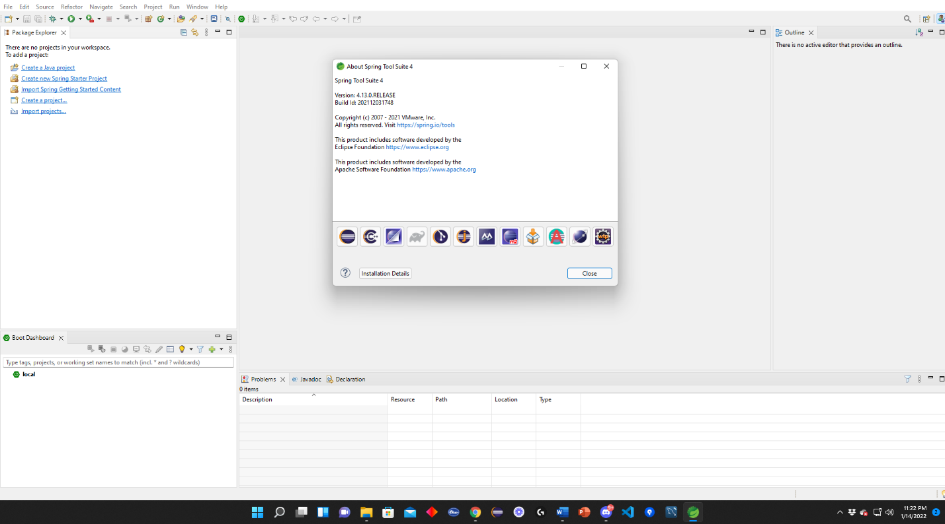

Console Output Running the Topic1-1 class

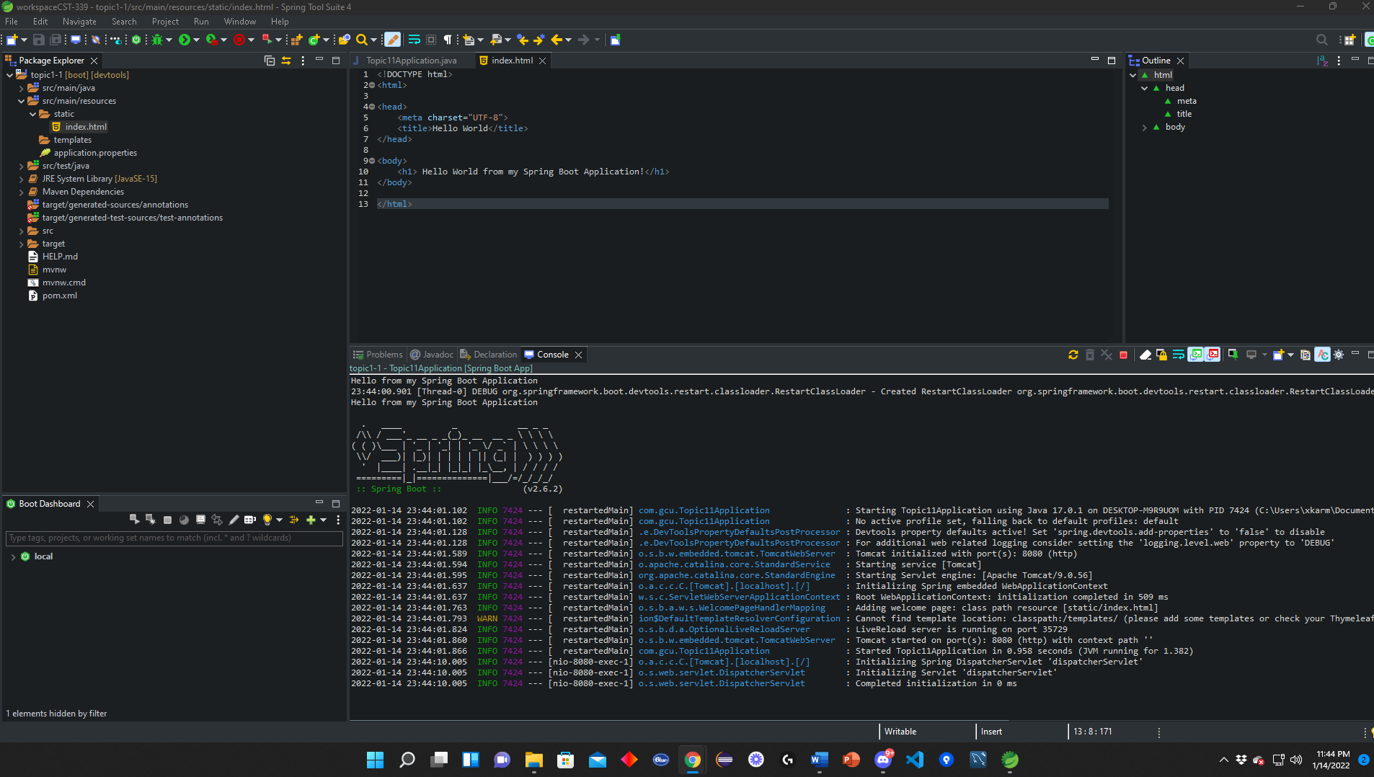

Whitelabel Error Page

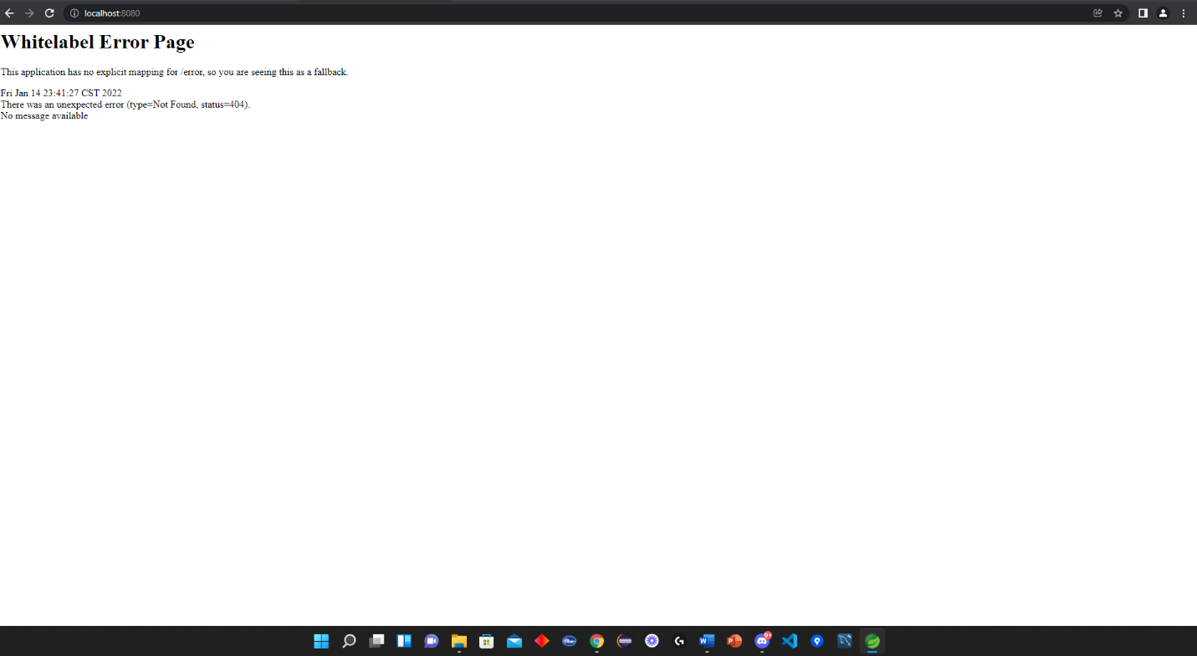

Hello world index.html screenshot

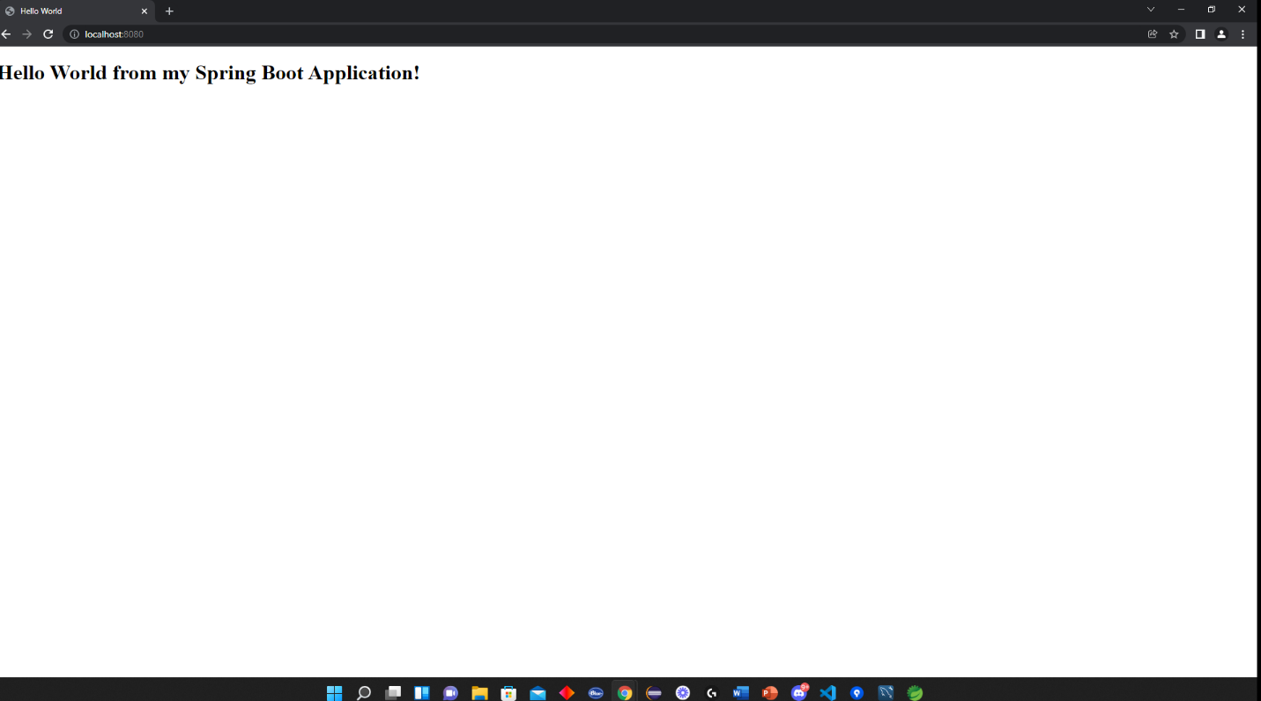

Hello World index.html page

